HOW TO GET TO YOUR DATA DELIVERABLES

- Using your credential, log into the portal following the link https://secure.hidiadvantage.net/

- Click on the HIDI ADVANTAGE ANALYTICS box below. Doing this will take you to a separate tab.
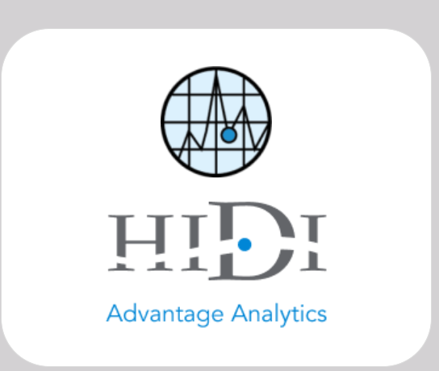

- On this page click on “Deliverables”; this will display the different deliverables for each state. Click on the desired state and that will take you to a page where you can download the data after entering a password.
